**Proposal for**



**{{title}}**

**({{rfp}})**

**United Nations Development Programme**

**{{dated}}**

**Submit to:**

**UNDP Liberia,**

UNDP Office in {{country_city}}

{{location}}

Contact Person: {{contact_per}}

{{email_id}}

**Submitted by:**

**Kamtech Associates Private Limited**

B-20, Janta Colony, Behind Pink Square Mall

Jaipur 302004(Rajasthan), India.

Email: md@kamtech.in, office@kamtech.in

Telephone: +91: -141-4108548, +91 7240000406  
Website: www.kamtech.in

Table of Contents

Section 1: Qualifications of the Service Provider 4

1.1. Company Profile: 4

1.2. Track Record 24

1.3. Certificates and Accreditation: - 68

1.4. Business Licenses: - 78

1.5. Self-Declaration 82

1.6. Details of contracts in the last 5 years for provision of similar services 83

1.7. Statement of Satisfactory performance within past 5 years 98

Section 2: Proposed Methodology for the Completion of Services 100

2.1. Background 100

2.2. Scope of the Service / Work 101

2.3. Outline Work Plan 110

Section 3: Qualifications of Key Personnel 115

3.1. Key Personnel and their relevant experience with specifics examples: 115

3.2. Resumes of Key Personnel 117

**Annuexures**

Annexure 5: Proposal Submission Form

Jaipur

{{date}}

To:

{{contact_per}},

{{location}}

{{email_id}}

**Dear Sir:**

We, the undersigned, hereby offer to render the following services to UNDP in conformity with the requirements defined in the {{rfp}} dated {{dated}}, and all of its attachments, as well as the provisions of the UNDP General Contract Terms and Conditions:



**Section 1: Qualifications of the Service Provider**

## **Company Profile:**

| **No.** | **Description** | **Detail** |
| --- | --- | --- |
|  | Proposer’s Legal Name | Kamtech Associates Pvt. Ltd. |
|  | Actual Country of Registration: | India |
|  | Year of Registration: | 1997 |
|  | Legal Structure | Pvt. Ltd. |
|  | Registration No. | No. 17-014243 of 1997-98 |
|  | Registration Act | Company Act 1956 (No. 1 of 1956) |
|  | GST No. | 08AAACK7619Q1ZW |
|  | PAN No. | AAACK7619Q(Photo copy enclosed) |
|  | TAN No. | TIN No. 08072108033 |
|  | CIN | U74999RJ1997PTC014243 |
|  | Key Shareholders | Total Three Directors   |  |  | | --- | --- | | **Name** | **DIN/PAN** | | AJAY KUMAR GUPTA | 0000773700 | | KALPANA GUPTA | 0001607883 | | SAKSHAM GUPTA | 0008033486 | |
|  | Countries of Operation: | India, Germany, Bhutan, Kenya, UK |
|  | Legal Addresses in Country of Registration: | **Registered Office:**  Ajay K Gupta, Managing Director  Kamtech Associates Private Limited  B-20, Janta Colony, Behind Pink Square Mall  Jaipur 302004(Rajasthan), India.  Email: [md@kamtech.in](mailto:md@kamtech.in), [office@kamtceh.in](mailto:office@kamtceh.in)  Telephone: +91: -141-2607931  [www.kamtech.in](http://www.kamtech.in) |
|  | Brief description of litigation history (disputes, arbitration, claims, etc.), indicating current status and outcomes, if already resolved. | No Litigation. We never had any disputes, arbitration, claims and or litigation. |
|  | Proposer’s Authorized  Representative Information: | Ajay Kumar Gupta  Managing Director  Kamtech Associates Pvt. Ltd.  Mobile: +91-9414046876, Phone: +91-141  4108548  E- mail: md@kamtech.in |



|  |  |
| --- | --- |
| **Offices in India** | **Abroad** |
| **Corporate Office** | **Germany – Liaison Office** |
| B-20, Janta Colony Jaipur- 302004 (Rajasthan) India Mob: +91-9414046876, +91-7240000407  Email: [info@kamtech.in](mailto:info@kamtech.in) | Mr. Saksham Gupta  Luise-Riegger-Strasse 54  Karlsruhe 76137  Germany  Mobile No.: +49-15217583377  Email: [Saksham.gupta@kamtech.in](mailto:Saksham.gupta@kamtech.in) |
| **Development Center** | **Kenya – Representative Office** |
| IT-23, IT Park, EPIP,  Sitapura Industrial Area, Jaipur - 302022 (Rajasthan) Tel:+91-141-2377559,2373226, 2371308 Email: office@kamtech.in Website: [www.kamtech.in](http://www.kamtech.in) | Mr. Oching Mbeo  3rd Floor, Ambassador Court  Block A, Suite 5,  Millimani Road,  Box 27303 -00100, Nairobi, Kenya  Cell : +254722768537 |
| **Branch Office – Balasore, Odisha** | **Bhutan – Representative Office** |
| C/o S.S. Agri Business Pvt. Ltd., Kuruda, Balasore, Odisha [INDIA] – 756065  Mob- 9828011010 | Mr. Phub Gyeltshen  Norlingangkha Building, Changangkha  P.B.No. 576 , Thimphu Bhutan  Phone No. 975 2 335378  Mobile No. 975 17111576 |
|  | **UK – Representative Office** |
| Kamtech Associates Pvt. Ltd.,  C/o Thought Agile Ltd.  Office: 1.01, BEC, 50 Cambridge Road, Barking, London – IG11 8FG  Phone Number: +44 77668 66199 (London)  Email: [hj@thoughtagile.co.uk](mailto:hj@thoughtagile.co.uk) |



**ABOUT KAMTECH:**

Established in 1997, **KAMTECH** is one of North India’s leading technology consulting company. With over 23 years of International experience, varied domain expertise, and a wide network of international alliance partners; Kamtech has earned professional repute in providing value added management, digital cum organisational transformation and engineering consulting services and solutions for multisectoral projects in agreed time frame with enhanced customer satisfaction.

With its head office in Jaipur (Rajasthan, India) and network partners across 7 countries, Kamtech offers clients cost effective high-fidelity total consulting solutions that are fine tuned to each client's specific requirements to face growing global business challenges. The company works across several domains viz. **IT Support and Solutions**, Turnkey Industrial Project Consultancy, Management Systems and Best Practices, International Markets, Technology and Investment Advisory, Outsourcing and Compliance Value Creation.

They have strong international project expertise of over 700 successful projects in countries like India, Kenya, Tanzania, Germany, Italy, Hungry, Romania, China, Brazil, Bhutan, DRC, Malaysia, Saudi Arabia, Iraq, Myanmar, Norway, and UK. Moreover, Kamtech is the only Indian company to receive two national awards consecutively, **National Award 2009 (First Prize)** from the President of India and **National Award 2008 (Special Recognition)** in Services Sector for outstanding performance by the Ministry of MSME, Government of India (GOI).

Some of the prominent clients include **UNDP**, JK Cement, Nucleus Software, OTRC Limited, Genus, Hindustan Salts Limited, Kirana King, NRDC, CG Corp, FICSI, various State Governments, Central Governments & Ministries. At the International level, the clients include Government of China, Government of Kenya, European Union, Royal Government of Bhutan and Ministry of Innovation and Industries, Brazil, Al Rajai group, Saudi Arabia and others.

The company has an extensive experience in developing web portals and mobile apps for complex development problems, over the years, Kamtech has successfully designed and **developed more than 120 websites, portals and applications for government and private sector in both industrial and consumer segment.**

Kamtech successfully competed Energy efficiency project in 90 rolling mills under **UNDP** (United Nations Development Program) project on their rolling mill cluster on all pan India basis in which three major clusters Jaipur, Raipur and Ludhiana were covered.

In 2017, Kamtech completed the Sectorial System of Innovation (SSI) survey of the cement industry and paper and pulp industry in India for **UNIDO Vienna**.

With their branch office in Germany, Kamtech has partnered with various European companies to offer unique solutions in the field of Augmented/Virtual/Mixed Reality, Machine Learning, Artificial Intelligence, Computational Intelligence and Smart City Technologies. With the COVID-19 impact, and the sudden need for digitalization, Kamtech is pleased to support companies/organizations with complete digital transformation support including building and implementing the required solutions.

The company has state of art in house expertise on a variety of industry sectors and latest projects which are complimented by its business associates through suitable MOU’s with other leading National and International consultancy organizations.

Following are the core services of company:

1. **IT Solutions and Customized Software development**

* Digital Transformation Strategy
* Web/App Development (Android/iOS/Windows)
* Customized Software Development
* Data Analytics
* Testing & QA
* Infrastructure Services
* Digital Advertising
* AI & ML
* AR|VR|MR
* GDPR Compliance Consulting & Training

At Kamtech, we help transform startups and businesses with powerful and adaptable digital solutions that satisfy the needs of today and unlock the opportunities of tomorrow. Our extensive team of software developers, engineers, DevOps, testers, quality analysts, data scientists and business analysts work dedicatedly with the company founders, CTOs, government organizations.

As a tech partner, we build remote tech teams and care about the right choice of technologies, great quality of code, effective communication and delivery of top-notch tech solutions. We use Agile approach and Scrum methodologies to ensure effective project management and timely delivery of work with complete customer satisfaction.

Company IT website: <https://www.it.kamtech.in/>

Our business acumen and experience in building innovative products and services allows us to recommend the most suitable technology and business solutions.

We work with the following technologies:

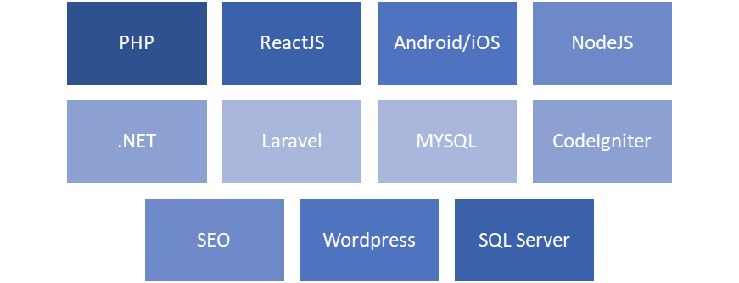

We provide technology solutions in a wide range of industries and sectors:

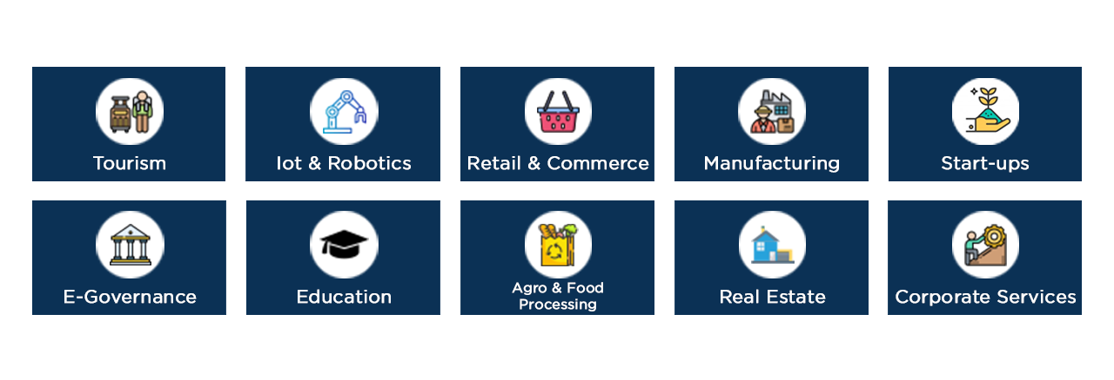

We offer customizable ready-to-deploy IT Solutions for various business needs:

* RPMS
* Token Display System
* AR Cloud
* AR B2C Marketing
* InterTrade ERP
* Real CRM
* Ticket Management System
* BPM Software
* Workflow Management
* Warehouse Management

1. **Consultancy Services**

* Market Research & Demand Analysis Research Studies
* Detailed Feasibility Studies and Detailed Project Reports [DPR]
* Economic Development & Investment Studies, Vision documents
* Economic & Financial Analysis
* Cluster Development and CFC Support
* Capacity Building & Needs Assessment
* Skill & HR Development
* Infrastructure Development
* Design and Engineering Services
* Construction & Monitoring/Supervision
* Risk Analysis & Concession Framework
* Turnkey Project Development / Transaction Advisory services
* Technology Sourcing, R&D Services
* **Survey & Data Analysis**
* Procurement Plan & Bid Strategy Formulation
* Vendor Selections, Promotion, Quality checks and due diligence services
* Joint Venture (JV’s), International investments and FDI services
* Business Plan Creation
* Start-up Mentoring & Incubation Support
* GIS mapping, Ground water, rain water harvesting studies and implementation





1. **Education and Skill**

We are working with Rajasthan Knowledge Corporation Ltd and Orissa Knowledge Corporation Ltd as their Service Provider Agency and have more than 100 IT Gyan Kendra’s on Franchise model delivering online education and skill across Rajasthan and Orissa. We also work with trade and industry bodies to identify/study skill gap for various job requirements / job openings and work with various employable youth to impart them the required skills and arrange the placements. We have developed a specialized international business Export/ Import documentation course and regularly conduct the same.

**Trainings offered:**

* Corporate Training
* Export Training Programs
* Executive Development Program
* Motivational Programs
* IT Training
* E-Learning Programs
* Internships
* Train the Trainer (ToT)
* Technical Skills Training
* B.Voc. Courses
* Job Oriented Courses
  + International Business
  + E-Tendering
  + GST Compliance

1. **ESG and Sustainability Services**







Kamtech is empaneled in various organizations i.e. Exim Bank, SIDBI, NSIC, NRDC, NIFTEM and others. We are associated with various National and International Organizations and Government bodies as implementation partner, support provider/agency, techno-commercial partner and training partner.

**PARTNERS**

| **#** | **Organization** | | **Kamtech Association** |
| --- | --- | --- | --- |
| **International** | | | |
|  | Aydon Consultants | **Aydon Consultants Group** – UK  (presence in 34 Countries) | Kamtech is having active participation with a leading global business Consultant Group – Aydon and providing services across the world. |
|  |  | **KINDA Group is Kenya’ leading consulting group** | Kamtech and KINDA group working together on many Kenya Government economic and industrial development projects. |
|  | ALTERNATIVES AFRICA Kingdom Business Network, Kabarnet Road, off Ngong Rd, Nairobi, KENYA | **Alternative Africa** provides an integrated ecosystem that offers affordable business development services, financial services and marketing services to youth-led micro and small enterprises for economic growth and job creation. | Kamtech to provide farm gate processing models, equipment and machinery, technology support, training & capacity building, market research and ICT support for Alternatives Farmpreneur initiative. Explore and Build potential partnerships with the industry, Government and scientific/technology entities in each country. |
|  |  | **FATE** specializes in monitoring and evaluation, quantitative and qualitative research, gender analysis and mainstreaming, gender implementation in programs, gender technical support in programming, policy analysis, program development, facilitation, training and capacity building in different sectors including Agriculture, Women’s Empowerment, Social Protection, Poverty Reduction, Technical and Vocational Education and Training (TVET) as well as Human, Women’s and Child Rights. FATE also provides logistical support to international actors working in our areas of expertise (such as data collection services, transcription, coding). We determine a good fit for a project to pursue when it is in our area of expertise. With its qualified and experienced team members, FATE consulting provides high quality services to clients. | Kamtech to work closely with Fate for Social Development and Economic Development support to FATE for African countries various development funding initiatives. |
|  | ARtist UG (haftungsbeschränkt) | **ARtist** is a German based company offering a Novel Advertisement & Product Placement Technology in  Augmented Reality (AR). With ARtist’s services it targets both B2B and B2C customers.  The product ARtist is currently offering is the location-based Augmented Reality mobile application AR.fx,  which is capable of creating, geo-placing, viewing, sharing and interacting with (animated) 3D content in  AR using smart devices such as smartphones. It enables users to generate their own AR content and to  interact with that provided by B2B and peer users. | Kamtech is working on potential use cases and projects in the following sectors (but not limited to) Religion/Mythology, Entertainment, Tourism, Retail/e-commerce, Education/Skill. |
|  | nuspirit GmbH, Germany | **Coworking0711 (nuspirit GmbH)** is a coworking space provider company based in Germany having its coworking spaces spread across various towns in Germany with principal Coworking space at Gutenbergstr.77a, 70197 Stuttgart. | (a) Establish and promote Rajasthan Stuttgart startup accelerator program;  (b) Offer opportunities to Startups and SME sector companies willing to explore the Indian and German markets  (c) Collaborate and provide all Innovation, IP Management platforms; to Startups and SME sector companies in respective countries  (d) Explore and Build potential partnerships with the industry, Government and scientific/technology entities in each country |
|  | Controlsoft Automatika Ltd., Hungary | **CONTROLSOFT AUTOMATIKA LTD.** was established in 1991 by Hungarian professionals, who had gained decades-long experience in the fields of electrical engineering and process control. The founders’ philosophy was to allow a wide range of users to access the opportunities that are provided by modern electrical and automation systems. The company continues to work along  the same line of principles and it is  100%-owned by Hungarian individuals. | Kamtech to represent Controlsoft’s business interest across various verticals in India and provide due diligence. |
| **National** | | | |
|  |  | **Bhartiya Skill Development University (BSDU) -**is the first Indian University to offer only skill-based programs and has established itself as a leading education provider with prime focus on holistic skills training based on Swiss Dual System using machinery and equipment procured from the best manufacturers all across the globe. | Kamtech and BSDU will work on joint research programs in the field of AI, Data Science, Industry 4.0; Skill Mapping; Startup and Entrepreneurship development; International Consultancy; Cluster Development – Setting up CFCs, supporting the sustainability and growth of MSEs. |
|  |  | **Carl Zeiss India** | Implementation partner for Aloka Vision Programme (initiative by Carls Zeiss to provide affordable and quality optical care to Rural India) for the state of Rajasthan and Orissa. |
|  |  | IFFCO Kisan has launched IFFCO Kisan mobile app to onboard the farmers and all the related business entities. | Kamtech is Business Implementation Partner for IFFCO Kisan new initiatives for the farmers and all related business stake holders. |
|  | client4 | **Centre for Development of Advanced Computing (C-DAC)** is the premier R&D organization of the Department of Electronics and Information Technology (DEITY), Ministry of Communications & Information Technology (MCIT) for carrying out R&D in IT, Electronics and associated areas. | Working as a skill and training partner for CDAC. We are providing hand holding support to implement the IT and Education Project conducted by CDAC. |
|  |  | **RKCL -** **Rajasthan Knowledge Corporation Ltd.**  Public Limited Company established in Rajasthan as a joint venture of Government of Rajasthan. | Program Support Agency of RKCL and having 150 IT Gyan Kendras across Rajasthan, imparting on line mass education delivery. We also proving job-oriented training program. |
|  | Image result for Doitc Rajasthan | **Department of Information Technology & Communication,**  **Government of Rajasthan** | Service Provider for operation of E-Mitra Network and Common Service Center (CSC) |
|  | https://pbs.twimg.com/profile_images/582885193851088896/yzWDZ3o7.jpg | **NDLM -** **National Digital Literacy Mission:** Department of Electronics and Information Technology (DEITY), Ministry of Communications & Information Technology (MCIT) | Working as a training partner and responsible for conducting digital literacy training program in the identified Districts/ Blocks/ Gram Panchayat that would impart to the beneficiaries. |
|  | Logo | **IGNOU - The Indira Gandhi National Open University (IGNOU),** established by an Act of Parliament in 1985, has continuously striven to build an inclusive knowledge society through inclusive education. It has tried to increase the Gross Enrolment Ratio (GER) by offering high-quality teaching through the Open and Distance Learning (ODL) mode. | Registered with IGNOU for conducting Management and Skill Development Courses. |
|  | http://adityatekkali.edu.in/images/istelogo.jpg | T**he Indian Society for Technical Education (ISTE)** is the leading National Professional non-profit making Society for the Technical Education System in our country. | Institutional member (Life) of ISTE and conducting various skill oriented short-term courses for industries |
|  | OKCL | **OKCL - *Odisha Knowledge Corporation Limited*** is a key to survival and development of people in the emerging knowledge era in Odisha. | Working as program support agency to OKCL for Human Resource and Skill Deployment. |
|  |  | **Food Industry Capacity & Skill Initiative (FICSI)** is a Not-for-Profit Organization, registered under the Societies Registration Act, 1860. The Council has been promoted by the Federation of Indian Chambers of Commerce and Industry (FICCI) with financial support by National Skill Development Corporation (NSDC).  “Creating a robust and vibrant ecosystem for quality education and skill development in the Food Processing Sector in the country”. | VTP (Vocational Training Partner) of FICSI (FICSI/TP/AFF/100) for organizing/ conducting vocational training program selected to Food sector including dairy  product development for India |

**EMPANELMENTS & ACCREDITIONS**

| **#** | **Organization** | | **Kamtech Empanelment** |
| --- | --- | --- | --- |
| 1 | http://www.nrdcindia.com/frontend/images/1549520589logo.png | **National Research Development Corporation (NRDC)**  (an enterprise of Department of Scientific and Industrial Research)  Ministry of Science and Technology, Govt. of India | Empaneled for commercializing technologies developed by NRDC. |
| 2 | NSIC - National Small Industries Corporation | **National Small Industries Corporation Limited**  (A Government of India Enterprise)  NSIC Bhawan, Okhla Industrial Estate, New Delhi – 110 020,  Tele: +91-11-26926275, 26926370 Fax: +91-11-26932075 | Registration as an SSI unit eligible for participation in the Central Government to Store Purchase Program.   1. Project Management Consultant Services 2. Consulting Engineer Services 3. Information Technology and Software development service 4. Skill development and Training Services 5. Business Support Services 6. Strategic Management Consultancy services 7. International Business Advisory services 8. Joint Venture/Investment Advisory Services 9. Market Survey & Assessment Services 10. Monitoring Evaluation & Impact Assessment Studies Energy efficiency, Environmental Issues, Geotechnical Survey and related works |
| 3 | http://www.sarkarinaukriwala.com/wp-content/uploads/2015/07/SIDBI.gif | **SIDBI – Small Industries Development Bank of India**, is the Principal Financial Institution for the Promotion, Financing and Development of the Micro, Small and Medium Enterprise (MSME) sector and for Co-ordination of the functions of the institutions engaged in similar activities. | Accredited Consultant for providing techno commercial analysis and review of projects for funding. |
| 4 | Government of Rajasthan | **Urban Development and Housing Department** Government of Rajasthan and Jaipur Development Authority JDA: are committed for systematic planning and development of cities and Jaipur. | Empaneled as Dedicated Consultant in UDH and JDA for Master Plan Development, Slum Free Cities and Project Management. |
| 5 | http://www.avantikalagram.com/images/dch-logo.jpg | **Development Commissioner (Handicraft), Ministry of Textile, Government of India: Department is implemented**  various developmental schemes at the central level, to supplement State's activities in the ***handicrafts*** sector in India. | Empaneled as Guiding & Monitoring Agency (GMA) under Ambedkar Hastshilp Vikas Yozana (AHVY), |
| 6 | C:\Users\Vikram\Desktop\Logo.png | **NIFTEM: National Institute of Food Technology Entrepreneurship and Management** is under the Ministry of Food Processing Industries (MoFPI) Government of India. | Empaneled with NIFTEM for Marketing Studies, Rural Development and Skill Development Programs. |
| 7 |  | **National Centre for Jute Diversification**, Government of India, Ministry of Textiles | Empanelment as Project Consultant for Jute Parks |

**MEMBERSHIPS:**

We are member of CII (Confederation of Indian Industry), Electronics and Computer Software Export Promotion Council (ESC), Quality Council of India, Indo American Chamber of Commerce, PHDCC and FORTI. Our Managing Director is Council Member of CII Rajasthan, Chairman ESC Rajasthan and member APO, Japan. He is also the Honorary rowing ambassador of Homabay County, Republic of Kenya.

* Confederation of India Industries (CII)
* Electronics and Computer Software Export Promotional Council (ESC), New Delhi
* Federation of Trade & Industries Rajasthan
* PHD Chamber of Commerce & Industry
* The Employer Association of Rajasthan

**AWARDS AND ACHIEVEMENT:**

* SAP Dare to Dream Award, Emerging Company of the Year 2018
* Best Employer Awards 2016, 2017, 2018 from The Employer Association of Rajasthan.
* State Explort Excellence Award Service Sector 2010-11
* National Award 2009 (First Prize) by President of India
* National Award 2008 in Service Sector for Outstanding Performance by Government of India
* **MSME-IT Excellence Gold Award 2011**
* Appriciation Letter by Princess Diya Kumari – MLA Sawai madhopur
* Various appluds and awards from clinets and stake holders from time to time









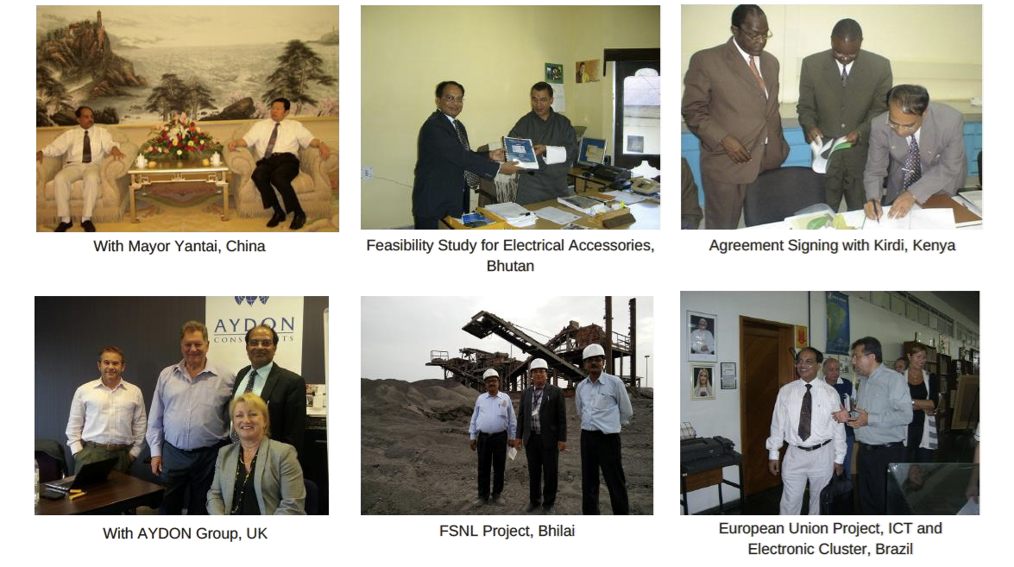



|  |  |
| --- | --- |
| **BRIEF LIST OF CLIENTS:** | |
| **Global Clients**   1. Ministry of Economic Affairs, Royal Government of Bhutan 2. Army Welfare Projects Ltd., Bhutan 3. Bhutan Board Products Limited, Bhutan 4. Rajhi Heavy Industries Company, Saudi Arabia 5. Kenya Industrial Research & Development Institute –Government of Kenya 6. Department of Industries - The Royal Govt. of Bhutan 7. Qingdao Government - China 8. Department of Industries- Government of Myanmar 9. Innovation Norway, Oslo, Norway 10. Otrac Limited, Hong Kong, PRC 11. DFID and British Council   Coloured Rocks- U.K.   1. Al‐Rafidain Agriculture Industries Company – Iraq | **Indian Clients:**  **United Nations Development Programme (UNDP), India**  **and Government of India organizations as such as:**   1. Micro, Small & Medium Enterprise Development Institute (MSME) - Government of India 2. National Small Industries Limited (A Govt. of India Enterprises) 3. Centre for Development of Advanced Computing (CDAC)- GOI 4. NIAM – Government of India 5. Hindustan Salts Limited Government of India Unit 6. Malviya National Institute of Technology, Jaipur [India] 7. Assam Industrial Development Corporation Ltd. (Government of Assam) 8. Ferro Scrap Nigam Ltd. (Mini Ratna, GOI) 9. FICSI (Sector Skill Council for Food Processing Industries) |
| **Government of Rajasthan Organization:**   1. Commissioner of Industries, Government of Rajasthan 2. Urban and Housing Development Department – GOR 3. MLA – Sawai Madhopur Office 4. Rajasthan Small Scale and Industries Corporation – GOR 5. District Poverty Initiative Project (DPIP Rajasthan) 6. Women & Child Development Department (Govt. of Rajasthan) 7. Rajasthan State Handloom Development Corporation - Govt. of Rajasthan 8. Rajasthan Missions on Livelihoods (Govt. of Rajasthan) 9. Rajasthan Bunker Sangh (Govt. of Rajasthan Unit) 10. RajCOMP - Govt. of Rajasthan 11. Sāmbhar Salt Ltd. 12. Directorate of Economics & Statistics (GOR) 13. Rajasthan State Ganga Nagar Sugar Mill Limited (Govt. of Rajasthan Unit) | |
| **Private Sector (selected few)**   1. Greentech Mega Food Park Limited 2. Rajasthan Cooperative Dairy Federation limited 3. RUFIL Dairy Private Limited 4. Rajdarbar Dairy Private Limited 5. Nucleus Software Limited 6. GENPACT Limited 7. Federation of Rajasthan Trade & Industries 8. Confederation of Indian Industries (CII) 9. Alwar Auto Component Manufacture Society 10. Mobile Industrial Parks Limited 11. Bullion Association Limited 12. J.K. Cement Limited 13. Kanoria Sugar & General Industries Limited 14. Greentech Mega Food Park Limited 15. Associates Soapstone Dist. Co. Pvt. Ltd., Jaipur [India] **and many more ……** | |

